Department of Computer Science

CuteBot Robots Programming Workshop



MakeCode for MicroBit

You will use the MakeCode platform to program your robot. It has a drag-and-drop interface (like Scratch), but you can also look at the Python code that it generates. Each robot has a MicroBit card which you need to connect to your computer via a USB cable. You can write code in any web browser ([makecode.microbit.org](http://www.makecode.microbit.org)), download the code as a .hex file, then drag and drop it on the MicroBit.

MakeCode Setup

Step 1: Log on to a computer using the login and password provided.

Step 2: Open **Google Chrome** and navigate to [makecode.microbit.org](http://www.makecode.microbit.org)



Step 3: Click on the “New Project” button.

Step 4: Give the project an arbitrary name, e.g. `My CuteBot Code’, and hit “Create”.

Step 5: Take a tour of the editor if you wish (optional step, **recommended to skip/close tour**).

Step 6: Click on “Extensions”

Step 7: Scroll down the list of extensions and add the “CuteBot” extension.

Create a Simple Test Program

Step 8: You can drag the relevant coloured blocks from the menu on the left. Select Variables -> Make a variable. Name it “sonar” (you’re free to use a different name if you want). Drag out “set sonar to 0” from variables, and replace the 0 with “HC-SR04 Sonar unit cm” which you can find in the CuteBot menu.

Step 9: Make the following sample:

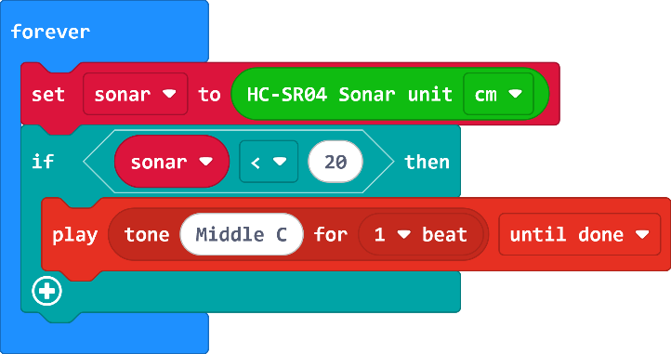

Step 9: Click “Download” button on the bottom left and follow the instructions (**choose to pair your micro:bit to your browser**). Note: It is recommended to disconnect the microbit from the cutebot for this step.

Executing the Code

Step 10: Disconnect the MicroBit from the computer, plug it into the CuteBot, place the CuteBot in the wooden pen, and turn it on using the switch at the back.

Activity 1 – Obstacle Detection (Ultrasonic Sensor)

Program the robot to continually move forward until it detects an object within 10cm. When it detects something, it should stop moving forward and move backwards for 1 second.

Activity 2 – Obstacle Avoidance (Ultrasonic Sensor)

As before, program the robot to move forward until it senses an object within 10cm. When it detects something, it should stop and rotate to the left by 90°. If there is no obstacle in this direction, the robot should move forward again for 1 second.

Challenge – Advanced Obstacle Avoidance (Ultrasonic Sensor)

Expanding on the previous activity, if the robot rotates left and still detects an obstacle, rotate it 180° so it’s facing to the right of the original obstacle. If this path is clear, move forward again for 1 second; otherwise turn another 90° to the right.

**Remark:** The robot will prioritise moving forward until it detects an obstacle, then it will look for an exit on the left, followed by the right. If there isn’t an exit on the right, it will go back the way it came.

At any point within the nested conditions where no obstacle detected, the loop will iterate again (from the beginning) so forward motion will start. Note that ‘forward’ is always relative to the current orientation of the robot.

*Obstacle Avoidance Algorithm*

REPEAT

Move forward slowly

IF obstacle detected

Stop forward motion

Rotate 90 degrees left

IF obstacle detected

Rotate 180 degrees right

IF obstacle detected

Rotate 90 deg right